**MODEL FARMS**

**For Years 5 & 6**

**Students and Families**

**HIGH SCHOOL**

**OPEN NIGHT**

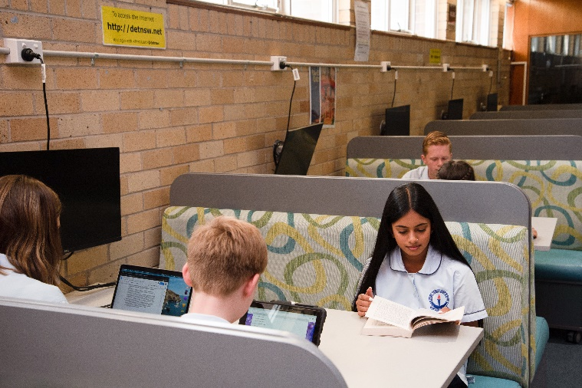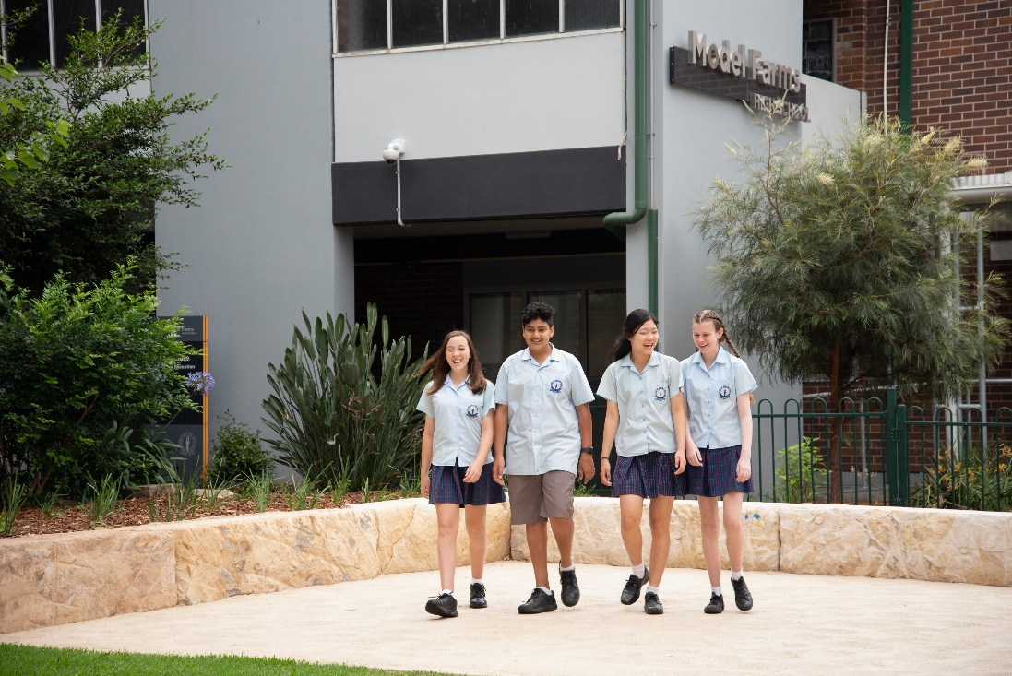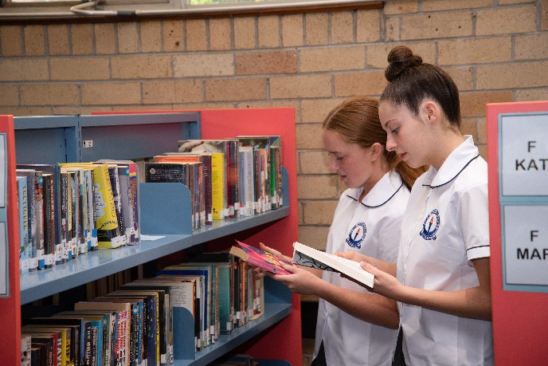

**SAVE THE DATE**

**TUESDAY 4th MARCH 2025**

**6:00pm – 8:00pm**

**Starting in the School Hall**

Performances

Displays

Tours

Information

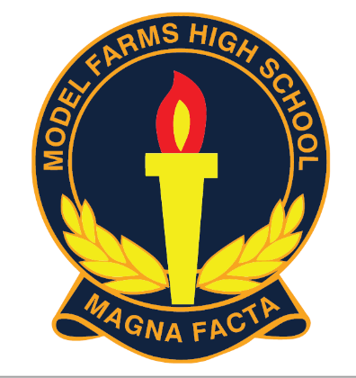

**Email**: modelfarm-h.school@det.nsw.edu.au

**Website:** www.modelfarms-h.school.nsw.gov.au

**Enquiries:**

**9624 3133**